REPORT OF THE SENATE ADVISORY COMMITTEE ON UNIVERSITY STRATEGIC PLANNING
June 2022

INTRODUCTION
The Senate Advisory Committee on University Strategic Planning (SACUSP) was created in 2020 as a vehicle to institutionally involve faculty at an early stage in the central administration’s long-term strategic decision-making process. The Committee membership and the terms of office may be found at https://academic-senate.utah.edu/committees/senate-advisory-committee-on-university-strategic-planning/

AREA OF COMMITTEE FOCUS FOR 2021-22.
After considerable discussion and reflection, the Committee decided it would focus its efforts this year in two separate, but related areas: (1) identifying the immediate needs of faculty to help inform administration decision-making in the next 3-5 years and (2) curating and highlighting certain faculty-specific information that should be considered by senior administrators, deans and department chairs as they work toward achieving the President’s announced goal of the University becoming a Top 10 University in terms of societal impact. These two areas of focus resulted in the production of three deliverables and a set of recommendations as described below. The three deliverables include
- a faculty needs and feedback survey and accompanying analysis of the survey results
- a document prioritizing what matters most to faculty and
- a compilation of the attributes/characteristics that a highly regarded “Top 10 “ faculty would possess.
This report embodies the collective work of the Committee, which reflects a broad cross-section of the campus. While not every committee member endorses every word of this report, it reflects the consensus of the Committee and was approved unanimously by the Committee.

DELIVERABLE ONE - A FACULTY NEEDS AND FEEDBACK SURVEY
The Committee was aware of two recent surveys of university faculty. These surveys provided important and useful information to the Committee, but we wished to ascertain certain information that was not directly solicited by either of these surveys. Consequently, the Committee designed and implemented its own faculty survey which focused primarily on identifying the challenges faculty currently face in fulfilling their responsibilities of teaching, research and service. While the results of all three surveys were considered by the Committee, our recommendations are principally informed by the Committee’s survey. A brief description of the three surveys follows.
- The CUTE Survey: In November of 2021 the University participated in the nationwide College + University Teaching Environment Survey (CUTE). This survey consisted of 48 questions with many subparts. The survey was primarily an attitudinal survey and was sent to any person who taught a course at the University during one of the semesters in 2021. The 4,360 recipients included instructors, teaching assistants and adjuncts in addition to tenure-line and career-line faculty. The response rate was approximately 15%. A copy of the survey instrument is attached as Appendix A.

- The Waggl (recently changed to Perceptyx) Survey. Since 2018, University of Utah Health Academics (UUHA) has annually surveyed their employees with an employee engagement survey. The 2022 survey, completed in February of this year, included both faculty and staff and consisted of 12 questions primarily designed to assess overall engagement, communication (including psychological safety), burnout and stress, respect, control and resources and career advancement. A 13th question was an open-ended question that changed each year. For 2022, the question was “What is one thing my supervisor could do to support my team at work?” The survey utilized a five-point Likert scale for the first 12 questions where respondents were asked to agree or disagree with various statements regarding their work environment. The survey tool is from a private vendor but was administered by the University HR Management for UUHA. The response rate was 36% across all UUHA entities, which includes the Colleges of Pharmacy, Health and Nursing, and the Schools of Dentistry and Medicine, as well as other non-academic entities. A high-level summary of the survey instrument, together with the overall faculty results from the 12 questions and a sample of the open-ended responses to the 13th question, is attached as Appendix B.

- The SACUSP Faculty Needs Survey. The Committee was cognizant of the fact that faculty survey fatigue was widespread on campus, due to the higher-than-normal number of surveys, including those that addressed the pandemic. Consequently, we opted to create a survey instrument that consisted of only five open-ended questions that could be answered in less than 15 minutes and would afford faculty the opportunity to identify the challenges and obstacles they face at the University, College and department levels in terms of fulfilling their responsibilities of teaching, research, and service. From March 14, 2022, through March 28, 2022, the Committee surveyed all full-time faculty who were actively engaged at the University in Spring semester and not on leave. Unlike the CUTE survey (which included adjuncts, teaching assistants and instructors) and the Waggl survey (which included faculty and staff) the SACUSP survey was limited to permanent, full-time faculty. 3,915 career-line and tenure-line faculty were surveyed. Great care was also taken to preserve the anonymity of respondents to encourage candid responses. The Utah Education Policy Center, led by its Director Andrea Rorrer and its Assistant Director for Research and Evaluation, Ellen Altermatt, assisted in the design, administration, analysis and reporting of the survey. The response rate from main campus faculty was 23.3 % and 11.2% from health sciences faculty, resulting in an overall response rate of 16.2%.

The survey report, attached as Appendix C, is well worth reading in its entirety, but several themes emerged from the results. These results are highlighted in Figure 1, which provides a summary of the primary themes from the findings. The left-hand side of Figure 1 calls attention to administrative actions that faculty indicated they were dissatisfied with and represented significant challenges that adversely impacted their research, teaching, and service as well as their satisfaction and feelings of value at the University. The right-hand side of Figure 1 provides a thematic summary of administrative actions that faculty indicated would support them, increase their satisfaction, and improve their feelings of value. The SACUSP survey results underscore the fact that multiple factors influence faculty experiences and perspectives at the University. These factors include: faculty load in research, teaching and service and leadership roles held; faculty rank and faculty appointment type; faculty College, Department, and/or Unit; resources available to the faculty; and faculty personal circumstances and experiences. After reviewing the SACUSP findings, one will notice that the results of the SACUSP Survey reflect issues (e.g., faculty performance and productivity; time allocations; well-being; compensation) found daily in news articles in public arenas such as the Chronicle of Higher Education or Inside Higher Education. To this end, the University of Utah is well positioned to address these issues in order to become a Top 10 Institution.

Figure 1. SACUSP Survey Summary
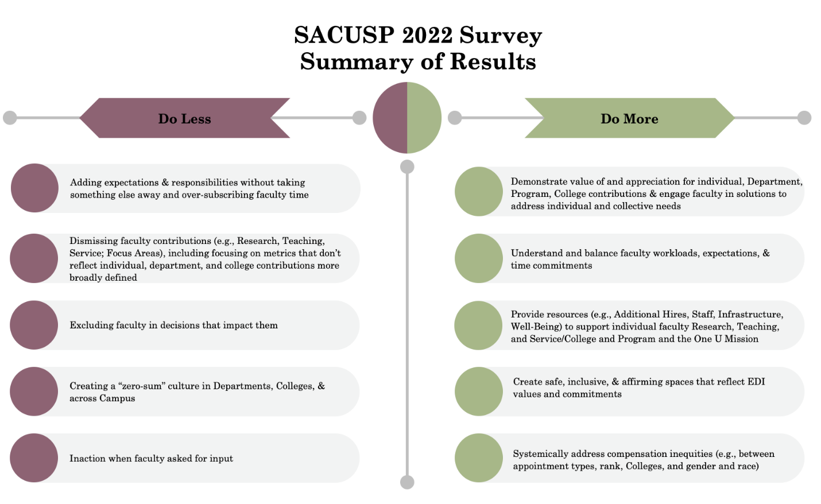

DELIVERABLE TWO - WHAT MATTERS MOST TO FACULTY
Taking into account the results of the three faculty surveys, the Committee members own knowledge, and input from their respective faculty colleagues, the Committee has identified the Top Eight areas of focus that matter most to faculty as a collective whole. The attached list, (Appendix D) is prioritized both in terms of fostering a highly satisfied and productive faculty and helping to move the needle on President Randall’s Top 10 societal impact goal. We readily acknowledge that the priority of individual faculty members may differ from the Committee’s priority depending on their faculty status, rank and department affiliation. Nonetheless, we hope this list is a starting point for discussion and we urge individual academic units to engage in a similar exercise. See recommendations number four below.

DELIVERABLE THREE - ATTRIBUTES/CHARACTERISTICS OF A HIGHLY REGARDED FACULTY
The Committee believes that achieving President Randall’s goal of the University of Utah becoming a Top 10 public university in terms of societal impact is an ambitious and multi-faceted undertaking. It will of course depend critically on significant additional funding and resources from the administration, through increased legislative appropriations, fund raising, and institutional support. Although achieving this goal will require buy-in from all segments of the larger University community (faculty; staff; colleges; departments; central administration; students; alumni; donors; and state government leaders), faculty will play an outsized role in progressing towards this goal. Attracting and retaining a highly productive and happy faculty, and providing them sufficient time and resources, is key to this endeavor. The Committee brainstormed on identifying those characteristics a top 10 faculty collectively would possess. That brainstorming produced the listing attached as Appendix E. We are aware that certain characteristics will be more important than others depending on the needs and perspectives of individual academic units and faculty members. We also recognize that sufficient financial resources will be a prominent factor in attaining these characteristics. This listing is aspirational in nature, and we hope it is instructive to administrators and other decision-makers in the effort of building a robust and highly regarded faculty.
RECOMMENDATIONS
The recommendations set forth in this report are intended to be constructive, and reflect an informed position made possible through the work of SACUSP this year. In no particular order of importance, the Committee makes the following six recommendations, some of which are directed to next year’s SACUSP committee; some of which pertain to the central administration; and some of which are for deans and department chairs.
- Each College and/or department on main campus should consider conducting a faculty engagement/climate survey in their respective unit like the Waggl survey done each year in Health Sciences or the SACUSP Survey. The value of providing the opportunity for faculty to give anonymous input and feedback to unit administrators and focusing improvements on issues that arise cannot be overstated. It would be useful for the University to provide shared resources to accomplish this type of climate assessment. The University’s existing Waggl/Pereceptyx license may allow academic units to utilize the survey tool. Main campus deans or department chairs interested in doing such a survey should contact Nina Linchenko in the Office of the Senior Vice-
President for Health Sciences. Ninalinchenko@hsc.utah.edu

- Each Dean and other college administrators should carefully review the findings and recommendations of the Faculty Needs Survey and specifically consider the comments from respondents.

- The University should reinstitute faculty exit surveys, whenever practical, to ascertain, among other things, primary motivations to leave, experiences while at the University, and feedback to improve the experiences of faculty at the University. These exit interviews could yield a wealth of information, albeit after-the-fact, that could be useful in future planning, particularly if they are used to inform action plans.

- The University should increase the support for administrators (chairs, deans, etc.) to
- identify cultural and structural concerns within their academic units;
- address the concerns in a systematic and inclusive way;
- facilitate appropriate follow-up on the efforts to address the concerns; and
- prioritize areas that are challenges to faculty well-being, productivity, and satisfaction.

For (a) this should include centrally funded surveys/breakout groups, salary reviews of faculty and staff, etc. at regular intervals such as during the 7-year Graduate School reviews. Additional specialized survey instruments when problems are suspected should also be provided (through HR, EDI office, etc.). Support for assessing these results should also be included.

For (b) the central administration should provide professionals (through HR, EDI, OEO, etc.) to help guide/coach college and department administrators. There could be several "toolkits" for departmental cultural improvement. An individual administrator cannot be expected to be an expert on how to manage institutional change within their units, so the U should provide professional support for this.

For (c) this should include mandatory follow-up and reporting to faculty and staff on the assessments, recommendations and changes generated from (a) & (b).

For (d) this includes the need for consistent and concerted actions that recognize and reward faculty for their engagement within and outside the University, both of which are essential to achieving the Top 10 Public University status of the University.

- Deans and/or department chairs should attempt to identify and prioritize what matters most to the faculty in their relevant academic unit, utilizing Deliverable Two above as a starting point of discussion. This information should be communicated to the relevant senior vice-presidents.

- The President and the two-senior vice-presidents should consider and utilize the attributes/characteristics listed in Deliverable Three in developing their strategy on how best to achieve the goal of becoming a Top 10 Public University in terms of societal impact.

- Next year’s SACUSP Committee should continue to (a) provide input to the President and the two senior vice presidents on new initiatives to achieve the desired Top 10 status and (b) provide feedback on existing efforts.

RESPECTFULLY SUBMITTED

Randy Dryer, Chair (Law & Honors)
Rohit Aggarwal (Business)
Teneille Brown (Law)
Thomas Cheatham (Pharmacy)
John Davis (Education)
Linda Edelman (Nursing)
Diego Fernandez (Mines & Earth Sciences)
Cindy Furse (Engineering)
Kevin Hanson (Fine Arts)
Janet Lindsley (Medicine, Basic Sciences)
Wanda Pillow (Cultural & Social Transformation)
Thomas Richmond (Science)
Michael Varner (Medicine, Clinical)
Christy Porucznik (Senate President, ex officio)
Sonia Salari (Senate President-elect, ex officio)

Appendix A: The CUTE Survey summary results
Appendix B: The Waggl Survey summary results
Appendix C: The SACUSP Faculty Needs Survey results
Appendix D: What matters most to faculty
Appendix E: Attributes/characteristics of a highly regarded faculty

